First Robotics
The TETRIX Parts that are used to build the robot are aluminum. They are fully compatible with the NXT lego mindstorm system. TETRIX parts are the original First Tech Challenge kit and are used in the United States and Internationally. They are heavy-duty, aircraft-grade aluminum parts. They have Trademarked hole patterns that allow for horizontal, vertically, and angular piece attachment. They are compatible for different purposes and designs. They are also re-usable.
What Is First Robotics Challenge?
My STEM PBL project is First Robotics Challenge. In this project I will show
- How to register for FTC robotics Competitions
- What the requirements are
-TETRIX Parts
-Wiring and Connection
-Robot C
-Sample Robot Design and Programming with step by step instructions
Diagram |  | Program-Robot C
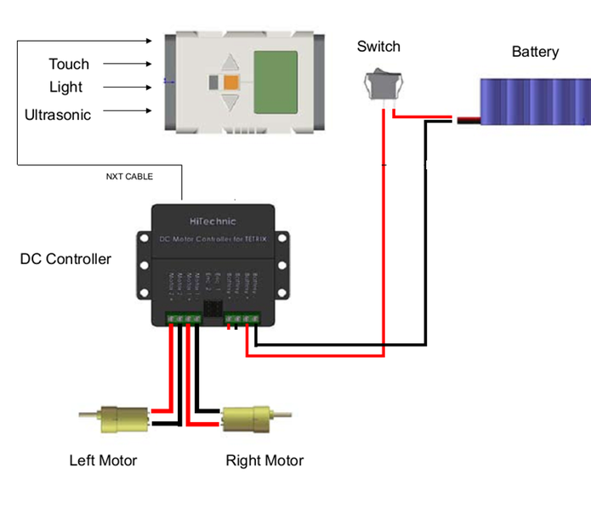 |  | #pragma config(Hubs, S1, HTMotor, none, none, none)  #pragma config(Sensor, S1, , sensorI2CMuxController)  #pragma config(Motor, mtr_S1_C1_1, leftmotor, tmotorTetrix, openLoop)  #pragma config(Motor, mtr_S1_C1_2, rightmotor, tmotorTetrix, openLoop, reversed)  //*!!Code automatically generated by 'ROBOTC' configuration wizard !!*//  #include "JoystickDriver.c"  task main()  {  while(true)  {  motor[rightmotor] = joystick.joy1_y1;  motor[leftmotor] = joystick.joy1_y2;  } }
FTC Robot |  | Designing
Sample 1 |  | Sample 2
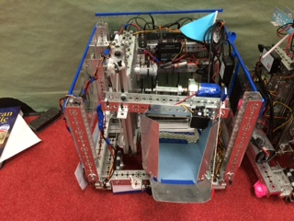 |  | 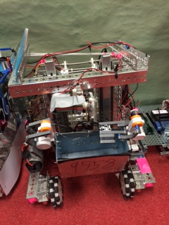
My Video | My Website

